Joint position paper by Finance Finland and Finnish Commerce Federation to the European Parliament and Council regarding the Commission’s proposal for a regulation on the legal tender of euro coins and banknotes

Summary
- The European Commission’s proposal for a regulation on the legal tender of euro coins and banknotes can drive up costs for consumers, businesses and society if it leads to the volume of cash being increased without a real need or demand.
- Digitalisation increases the range of different kinds of self-service concepts in all types of services. Self-services are usually paid for with digital payment methods.
- The proposed regulation can hinder the development and adoption of innovations (including instant payments and the digital euro) by interfering with the natural trends of cash usage. Hindering innovation can stunt economic growth that could otherwise be promoted with more efficient payment solutions.
- The proposed regulation can increase the level of physical threat, crime and insecurity in society. Cash usage is connected with the grey economy. EU-level regulation enacted to curb tax evasion, money laundering and other illicit activities already contains restrictions on cash payments (e.g. discontinuation of 500-euro banknotes, upper limit on large cash payments). This must be taken into account in future work on the proposal.
- Customer behaviour and the volume of cash in circulation in the retail payments sector vary widely between different European countries and even within a single country. Any potential regulation in this area must leave sufficient national discretion to member states.
- Payment methods must be considered as a whole. The majority of payments are already digital. Citizens receive income directly on their personal bank accounts (salaries, pensions, benefits) and handle the funds predominantly digitally (credit transfers through online or mobile banking, card and mobile payments, direct payments). Social security benefits are no longer paid out in cash or with vouchers, which have been replaced with e.g. prepaid debit cards that have limited use based on the benefit they are linked with. Retail consumption is moving increasingly online into e‍-‍commerce, where cash payment is not an option.
- Increasing the use of cash will not improve the inclusion of vulnerable groups or financial preparedness as such. For some vulnerable groups, a digital payment instrument can actually be simpler and easier to handle than cash. Digital solutions may also be essential during crises when the use of cash can be difficult (e.g. pandemics, armed conflicts). Cash will, of course, also continue to have its own uses. However, the challenges of inclusion, the needs of vulnerable groups and crisis management are not in the scope of the regulation on the legal tender of euro cash.
- Cash is a medium of payment issued by a central bank. If there is no market-driven use for cash, the central bank must contribute to the maintenance of cash as a payment method and the expenses incurred thereof.

What are the objectives of the Commission’s proposal for a regulation on the legal tender of euro coins and banknotes?
The Commission proposal for a regulation on the legal tender of euro cash and the proposal for a digital euro were published together as the Single Currency Package on 28 June 2023.
The key objectives of the legal tender proposal are:
- setting out, for the first time in secondary legislation, a definition and regulation of legal tender for cash,
- ensuring that the physical form of central bank money, euro cash, remains present, available and accepted by all euro-area residents and enterprises, and
- regulates the meaning of legal tender of the existing physical form of the euro and the digital version of the euro to ensure consistency among the two forms of public money.

Availability and acceptance of cash are on a good level in Finland
In Finland, cash is widely available and a widely accepted payment method. The provision and pricing of banks’ cash services is supervised by the Finnish Financial Supervisory Authority (FIN-FSA). The availability and acceptability of cash is monitored by the Bank of Finland on an annual basis, and the central bank also steers the market with its own recommendations. This has worked well, and there is no evidence of any significant problems related to the availability or acceptability of cash in Finland –both have remained on a good level for a long time. According to the FIN-FSA’s annual survey on basic banking services, cash services also continue to be readily available in the country.
Cash is widely accepted in physical retail shops and stores. All supermarket chains accept cash as a payment method. According to the European Central Bank’s study on the payment attitudes of consumers in the euro area (SPACE), over 80% of points of sale in Finland still accept cash even though the use of cash continues to decrease. All the daily essential services provided by the private sector (food and daily supplies, pharmacies) accept cash.
In contrast, the public sector is almost fully cashless in spite of the sector’s significant role in Finnish society. Public sector services and state-owned companies have all but fully abandoned the use of cash or at least substantially limited its acceptance: health care charges are invoiced, taxes and social security benefits are paid as credit transfers, public transportation tickets are bought by card or online, etc. Making the acceptance of cash mandatory would raise costs for both public administration and taxpayers.
In Finland the distribution of cash takes place primarily via an extensive network of cash ATMs, in addition to which cash also enters circulation through points of sale. The Finnish ATM network serves the general public regardless of the user’s bank or nationality, and the majority of cash withdrawals are card-based. Some bank offices still provide withdrawal services to their own customers also without a payment card. In some cases, bank offices can also send cash to their customers via registered mail.
According to the Bank of Finland’s cash statistics, the number of cash ATMs increased by 18% between the years 2016 and 2022. At the same time, the total euro amount of withdrawn cash has decreased. Between 2016 and 2022, the euro amount of cash withdrawals decreased by 42% and the number of withdrawals by 54%. In Finance Finland’s survey (2022), 17% of the respondents said they withdrew cash rarely or never. The same proportion of respondents said they wanted their banking services fully digital. Without demand, it is not reasonable to increase the availability of cash.

Finnish consumer behaviour diverges from the European mainstream in retail payments
According to the Bank of Finland’s consumer survey conducted in 2024, only 7% of Finns use cash as their preferred payment method in daily purchases. Cash and electronic payment methods (payment card and mobile payment) were used equally side by side by 2.7% of the respondents. Electronic payments were the overwhelmingly most common way to pay, with payment cards being the primary payment method for 83% of the respondents.
Finland differs from the rest of Europe in retail payment behaviour. Finland and the other Nordic countries use very little cash compared to countries in Middle and Southern Europe, for example. In Finland, wages and social benefits are paid directly into bank accounts. It naturally follows that retail payments are also primarily made using digital payment methods.

Cash infrastructure in Finland
Cash is a medium of payment issued by a central bank. The Bank of Finland has reduced its own operative role in the cash supply chain, and the role of commercial entities has grown in proportion. Over the course of three decades, the Bank of Finland gradually dismantled its network of regional offices, closing a total of 12 offices between 1992 and 2019. Today, it has a single remaining cash centre, and the primary transportation of cash is handled by private cash-in-transit companies.
Some European national central banks have stepped in to help with the upkeep of the cash supply chain in their country when its market-based maintenance has become uneconomic. This has helped secure the conditions for the continued use of cash.

Potential impact of the Commission’s proposal
General
The Commission proposal does not recognise certain trends and developments in cash usage that have significant relevance to Finland. The chief reason behind the declining use of cash in Finland is changed consumer demand. The cash as legal tender proposal does not offer solutions to this decreasing cash usage, the growing cost of cash management or the inclusion of vulnerable groups in the increasingly digitalised retail payments sector (economic and digital inclusion). Neither does the Commission proposal take into account security concerns (shop robberies, counterfeiting and money laundering) or the digitalisation of self-services such as unattended shops and vending machines (including electric vehicle charging stations and fuel stations).
The proposed regulation will not improve inclusion
The cash as legal tender proposal is frequently justified with considerations of inclusion. However, it needs to be acknowledged that steering vulnerable groups to using more cash may also contribute to digital exclusion and the inability to use digital services, which in the modern world are essential for personal financial management (economic inclusion) and access to important public services, such as personal healthcare information. Digitalisation enables the genuine privacy and tailoring of services to vulnerable groups and thus improves inclusion. Such services can help maintain or extend a person’s capacity to live independently. They also make it easier to render personal assistance to individuals with special needs. Vulnerable groups must not be steered away from digital services but rather empowered and encouraged in their use.
Cash will retain its status as a payment option alongside digital payment solutions. Essential consumer services provided by the private sector will continue to accept cash also in the future. There are consumers for whom cash or another non-digital payment method is the only possible way to pay, and who need non-digital services either for temporary or permanent reasons. The cash as legal tender regulation cannot solve the problems of vulnerable groups (immigrants, minors, assisted persons, persons under guardianship, persons without official or valid personal identification documents, persons with cognitive or motor impairments, etc.). Cash use may also be based on individual preference or a conscious decision to avoid digital services in general. The Finnish private sector is strongly committed to maintaining cash services. In the public sector, however, cash service is not supported, and this difference is important to recognise.
Cash is used especially by young people. In Finance Finland’s survey (2022), 46% of respondents aged 12 to 15 years said they only use cash, which they receive from their parents or grandparents, for example. Digital payment solutions for minors are currently in development.
Increasing the volume of cash will increase costs
Consumer behaviour is changing, and regulation can to some extent attempt to steer this change. Further work on the cash as legal tender proposal must involve the comprehensive assessment of consumer needs in order to find out if consumers are actually willing to increase their cash usage. If the volume of cash is artificially increased through regulatory means, costs to businesses may rise. The rising costs will ultimately be paid by consumers in the form of more expensive services or higher taxes.
Finnish society is growing increasingly digitalised, and different kinds of unattended service solutions are becoming more common. These include, for example, unattended shops, self-checkouts and vending machines as well as electric vehicle charging stations, which only accept digital payment methods. Adding the option to pay with cash into existing unattended points of sale would be expensive, cause additional costs to companies and also make the services more attractive targets for criminals.
Regulation must not create a situation in which companies are required to build and maintain payments infrastructure that is unlikely to be actually used by consumers. It would generate substantial additional costs that would be paid ultimately by consumers.
If the acceptance of cash is regulated, the use of cash in unattended services must be kept voluntary.
It is important to note that increasing the availability and acceptance of cash would require the updating or even rebuilding of existing infrastructure, products and services to make them cash-compatible. The volume of cash has previously been reduced with various EU-level guidelines and measures, which should be reviewed. Creating artificial demand simply for the sake of regulation seems odd.
Cash does not improve security or curb the grey economy
Security concerns related to the use of cash have not received enough attention in the regulatory proposal or its impact assessments.
Cash has a significant connection to grey economy activity and money laundering. It enables tax evasion and off-the-books transactions. Cash is also a key incentive behind store robberies, which expose the employees and customers to physical threat. Cash ATMs are also targeted.
Cash usage involves risk-based assessment, which can make other payment methods preferable over cash.
If the acceptance of cash is regulated, the regulation must account for security concerns and permit the refusal of cash payments on grounds of security.
Cash has an environmental impact
In the proposal text, the Commission states that the proposal is not expected to have any environmental impact. However, if the volume and use of cash is increased, the need for cash deliveries may increase, and more transport kilometres mean a bigger carbon footprint.
The number of primary cash transportations has decreased as the national central bank has cut its number of cash centres down to one. According to a study by the Bank of Finland from 2020, the kilometres travelled in cash supply in Finland annually amount to over 9 million. It is clear that increasing the use of cash involves environmental impacts and substantial costs.
Cash ATMs serve consumers 24/7 and thus maintain a constant energy consumption. The various stages in the processing and handling of cash use up plastic and other packaging materials as well as resources. Increasing the volume of cash would increase the consumption of plastic and other materials.
The proposal can give rise to market disruption
The proposed regulation may distort the development of other payment methods and the natural decrease in cash usage and demand.
In Finland, payment cards surpassed cash as the preferred payment method over 20 years ago. The role of cash as the most important way to pay for daily purchases started to decline in 1999, and the pandemic gave the majority of remaining cash users the final impetus to switch to payment cards. Established card users adopted mobile payment methods, and many tried out online services for the first time or increased their use of online services from before. This trend grew more pronounced during the pandemic and shows no sign of backpedalling. It is also important to note that the proposal’s treatment of different sales channels is unequal: the obligations imposed in the proposal only target physical stores and do not affect online stores to any extent.
EU regulation must not restrict consumers’ right to adopt efficient, digital payment methods.
Traditional services and operating models have changed. Daily food and supplies can now also be ordered online for home delivery or self-pickup. Pharmacies have introduced similar services. Hospital pharmacies and medicine dispensaries, which organise the public healthcare pharmaceutical services in hospitals and healthcare centres, are cashless, as are the outpatient pharmacies which supply medicines to patients in home care or service housing facilities. The proportion of electric vehicles is steadily growing, and their charging stations do not accept cash payments.
Cash does not automatically support preparedness and continuity
Cash functions as an alternative to digital payment methods. Maintaining a diverse range of payment methods improves resilience and the security of supply. However, it is important to note that the use of cash also requires electronic POS systems, functional telecommunications and cash management services. ATMs also depend on an operational power grid. In other words, cash in itself is not a failsafe solution in major incidents or crisis situations in society. Securing telecommunications and electricity supply is of utmost importance to maintaining the resilience of all payment methods. It is also essential that consumers prepare for disruptions in society by keeping cash reserves and several separate digital payment methods.

What should be taken into account in future work on the EU regulation on the legal tender of euro coins and banknotes?
- The proposed obligations pertaining to the availability and acceptability of cash involve several problems. Freedom of contract must not be restricted with regulation ‒ companies must retain the possibility to choose which payment methods they accept and, through these choices, maintain competition in retail payments and cash management services. Making the acceptance of cash mandatory could hinder the development of more efficient payment methods.
- The acceptable reasons for refusing cash payments must be expanded. Companies must be permitted to refuse cash payments on grounds of security, and unattended use cases must be ruled outside of the scope of mandatory obligations.
- If cash is to be regulated at the European level, member states must be allowed sufficient national leeway in their transposition and implementation to ensure that national specificities can be taken into account.
- The proposal’s evaluation criteria only focus on the availability and acceptance of cash. The demand side – consumer needs and willingness – are not addressed at all. The use of and need for cash should be evaluated in the broader context of social change. Ex-post evaluation should examine regional differences in payments, the availability and use of general-purpose payment methods and cash usage trends. The payments sector is undergoing rapid change, and it is vital that the market and its development are monitored using both quantitative and qualitative methods. The decision to use cash is influenced by many factors, which must not be ignored. Variation between individual countries can be significant. National regulation has been developed on the basis of national perspectives.
- In Finland, the national security of cash supply is almost fully in the hands of private entities. Instead of regulating on the legal tender of euro cash, the Commission, the European Central Bank and national central banks should take measures to strengthen the position of central-bank owned payment methods. The central bank should contribute to the infrastructure and costs of cash management and thus secure the availability of the central-bank issued payment method for consumers, merchants and businesses.
- Cash has societal significance. The future of cash does not depend on banks or the commercial sector ‒ its fate is ultimately decided by consumers. As cash is a medium of payment issued by a central bank, central banks must also be in a key role in the provision of cash services.

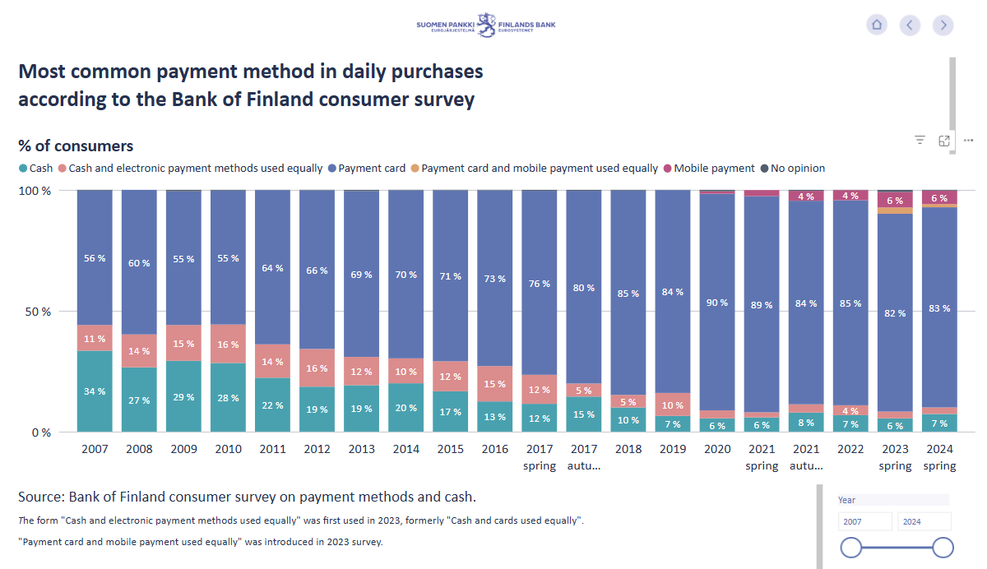
Annexes
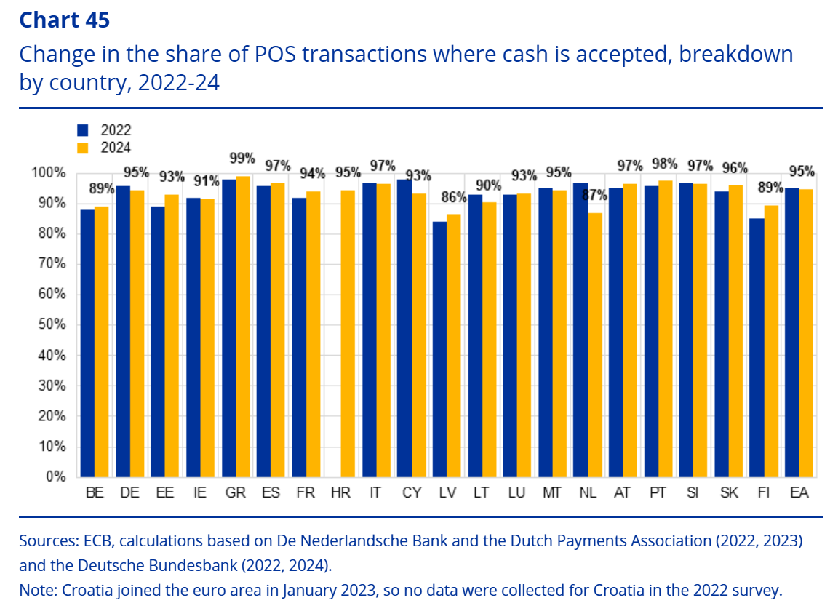

Source: Space 2024 Study on the payment attitudes of consumers in the euro area (SPACE)

